**SOUTHERN REGONAL PLANNING PANEL**

**SUPPLEMENTARY ASSESSMENT REPORT**

|  |  |
| --- | --- |
| **Panel Reference** | **PPSSTH-83** |
| **DA Number** | DA2021/011 |
| **LGA** | Snowy Valleys Council |
| **Proposed Development** | Proposed waste management facility for the purpose of sorting and composting a maximum of 10,000 tonnes per annum of organic material, including food organics garden organics (FOGO), and associated access and supporting infrastructure and associated site works. |
| **Street Address** | Lot 1 DP 197308 Snowy Mountains Highway, Gilmore NSW 2720 |
| **Applicant/Owner** | Snowy Valleys Council |
| **Date of DA lodgement** | 21 January 2021 |
| **Number of Submissions** | Two (2) |
| **Recommendation** | Approval, subject to conditions. |
| **Regional Development Criteria (Schedule 6 of the SEPP (Planning Systems) 2021** | Waste management facilities or works that meet the requirements for designated development (clause 7 of Schedule 6). |
| **List of all relevant s4.15(1)(a) matters** | * Environmental Planning and Assessment Act 1979 * Environmental Planning and Assessment Regulation 2000 * Protection of the Environment Operations Act 1997 * National Parks and Wildlife Act 1974 * Biodiversity and Conservation Act 2016 * State Environmental Planning Policy (Planning Systems) 2021 * State Environmental Planning Policy (Resilience and Hazard) 2021 * State Environmental Planning Policy (Transport and Infrastructure) 2021 * State Environmental Planning Policy (Biodiversity and Conversation) 2021 * Tumut Local Environmental Plan 2012 * Snowy Valley Development Control Plan 2019 |
| **List all documents submitted with this report for the Panel’s consideration** | 1. NSW Environmental Protection Authority General Terms of Approval 2. NSW Department of Planning and Environment Biodiversity and Conservation Division (BCD) Correspondence 3. Aboriginal Cultural Heritage Assessment 4. Heritage NSW General Terms of Approval 5. Amended Recommended Conditions of Consent |
| **Report prepared by** | Lachlan Rodgers and Jeremy Swan, The Planning Hub – Independent Town Planning Consultant on behalf of Council |
| **Report date** | 1 November 2022 |

|  |  |
| --- | --- |
| **Summary of s4.15 matters**  Have all recommendations in relation to relevant s4.15 matters been summarized in the Executive Summary of the assessment report? | **Yes** |
| **Legislative clauses requiring consent authority satisfaction**  Have relevant clauses in all applicable environmental planning instruments where the consent authority must be satisfied about a particular matter been listed, and relevant recommendations summarized, in the Executive Summary of the assessment report?  *e.g. Clause 7 of SEPP 55 - Remediation of Land, Clause 4.6(4) of the relevant LEP* | **Yes** |
| **Clause 4.6 Exceptions to development standards**  If a written request for a contravention to a development standard (clause 4.6 of the LEP) has been received, has it been attached to the assessment report? | **Not Applicable** |
| **Special Infrastructure Contributions**  Does the DA require Special Infrastructure Contributions conditions (S7.24)?  *Note: Certain DAs in the Western Sydney Growth Areas Special Contributions Area may require specific Special Infrastructure Contributions (SIC) conditions* | **Yes** |
| **Conditions**  Have draft conditions been provided to the applicant for comment?  *Note: in order to reduce delays in determinations, the Panel prefer that draft conditions, notwithstanding Council’s recommendation, be provided to the applicant to enable any comments to be considered as part of the assessment report.* | **Yes** |

**Table of Contents**

BACKGROUND 5

PURPOSE OF REPORT 5

SUMMARY OF RECOMMENDATION 5

RESPONSE TO BRIEFING ITEMS 6

THE SUITABILITY OF THE SITE 15

THE PUBLIC INTEREST 15

CONCLUSION 16

RECOMMENDATION 16

**Attachments**

1. NSW Environmental Protection Authority General Terms of Approval
2. NSW Department of Planning and Environment Biodiversity and Conservation Division (BCD) Correspondence
3. Aboriginal Cultural Heritage Assessment
4. Heritage NSW General Terms of Approval
5. Amended Recommended Conditions of Consent
6. Biodiversity Assessment

### BACKGROUND

On 25 October 2022, a briefing was held with the Southern Regional Planning Panel (the Panel) for DA2021/011 which proposes the construction of a waste management facility for the purpose of sorting and composting a maximum of 10,000 tonnes per annum of organic material, including food organics garden organics (FOGO), and associated access, supporting infrastructure and associated site works at Lot 1 DP 197308 Snowy Mountains Highway, Gilmore.

During the briefing the Panel sought clarification on the following items to allow for the application to be progressed to electronic determination:

1. *Clarification regarding the retail of end products and whether there are any implications for traffic/parking*
2. *Consideration of potentially offensive development (odour) against the provisions of the Resilience and Hazards SEPP*
3. *Make it clear that any increase in tonnages on the site above 3,000 tpa will be sought through changes to the amended license issued for the operation*
4. *Consideration of the objectives of the IN1 zone*
5. *Resolution of any issues raised by BCD including the need for conditions to close out residual matters*
6. *Expand on the Heritage NSW findings and the rationale behind the GTA’s applying to the whole site.*
7. *Review and update the draft Conditions to specifically refer to recommendations in the specialist reports*

The Panel noted that it was satisfied that the proposed development is a suitable use of the site and approval of the proposal is in the public interest subject to further information being provided to satisfy the above items.

### PURPOSE OF REPORT

The purpose of this supplementary report is to provide a response to the items that the Panel sought further clarification on at the briefing held on 25 October 2022 in relation to DA2021/011 at Lot 1 DP 197308 Snowy Mountains Highway, Gilmore.

### SUMMARY OF RECOMMENDATION

That the Panel grant consent to DA2021/011 consisting of the construction of a waste management facility for the purpose of sorting and composting organic material and associated site works pursuant to Section 4.16 of the Environmental Planning and Assessment Act 1979 subject to the conditions contained in this report.

### RESPONSE TO BRIEFING ITEMS

1. **Clarification regarding the retail of end products and whether there are any implications for traffic/parking**

The applicant has confirmed that once the facility meets the NSW Environmental Protection Authority’s (EPA) licensing requirements, becomes operational and the product meets the relevant classification the product will be sold onsite from the existing Tumut Waste and Recycling Centre (TWRC) at the northern end of the site.

TWRC includes a recycling facility that manually sorts the Council’s recycling stream into a premium product, a singulator machine for the container deposit scheme, a waste transfer shed, a second-hand shop, and transfer station drop-off points for waste and recycling.

Members of the public can currently access TWRC to dispose of waste and recycling, utilise the container deposit scheme and purchase goods at the second-hand store. TWRC provides adequate vehicular access and parking facilities for members of the public accessing the site in vehicles and with trailers. Refer to Figure 1 below for a site aerial of the existing TWRC and associated access and car parking.

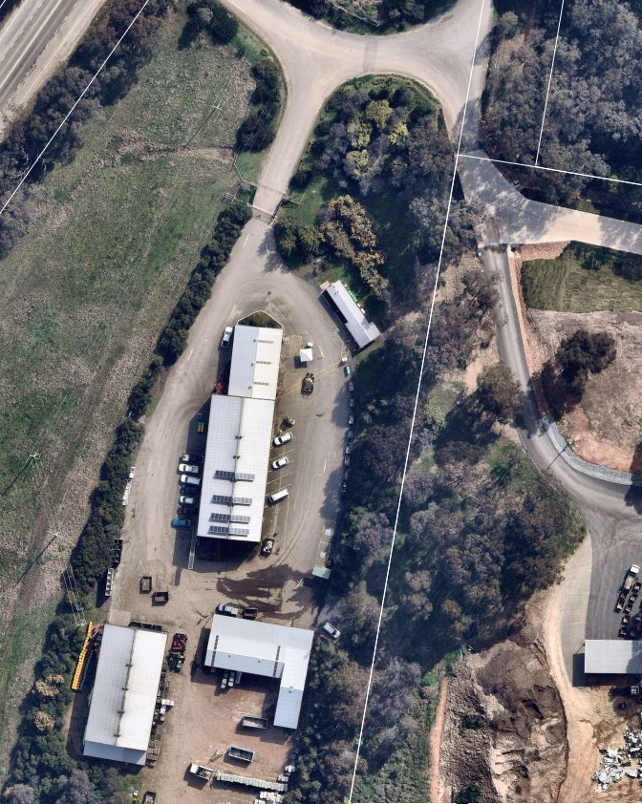

*Figure 1 – Site Aerial of the existing TWRC and associated access and car parking (Source: Nearmap).*

The retailing of the product processed at the proposed composting facility will be bagged and sold at the existing secondhand shop with the potential to also provide larger quantities once production increases. The sale of the product will be ancillary to the existing TWRC facility which currently accommodates members of the public disposing of waste and recycling, utilising the container deposit scheme and the purchase of goods at the second-hand store.

The introduction of the sale of the product will not result in any significant increase in vehicles accessing the site as it will be ancillary to the existing operation onsite. The TWRC is a large facility which has sufficient vehicular access and parking to accommodate any increase in access to the site by the public as a result of the proposed development.

No public access will be permitted to the composting facility.

1. **Consideration of potentially offensive development (odour) against the provisions of the Resilience and Hazards SEPP**

*State Environmental Planning Policy (Resilience and Hazard) 2021*

*Chapter 3 – Hazardous and Offensive Development*

Chapter 3 of the SEPP requires the consent authority to consider whether the proposal is a potentially hazardous or offensive industry that without the implementation of appropriate impact minimisation measures would, or potentially would, pose a significant risk in relation to the locality, to human health, life or property, or to the biophysical environment.

*Definitions of “hazardous industry” and “offensive industry”*

*hazardous industry means a development for the purposes of an industry which, when the development is in operation and when all measures proposed to reduce or minimise its impact on the locality have been employed (including, for example, measures to isolate the development from existing or likely future development on other land in the locality), would pose a significant risk in relation to the locality—*

*(a) to human health, life or property, or*

*(b) to the biophysical environment,*

*offensive industry means a development for the purposes of an industry which, when the development is in operation and when all measures proposed to reduce or minimise its impact on the locality have been employed (including, for example, measures to isolate the development from existing or likely future development on other land in the locality), would emit a polluting discharge (including, for example, noise) in a manner which would have a significant adverse impact in the locality or on the existing or likely future development on other land in the locality.*

The consent authority is required to undertake a preliminary risk screening analysis to determine if the proposal is deemed, by definition, to be a potentially hazardous or offensive industry. Should it be deemed that the development is potentially hazardous, a preliminary hazard assessment would be required.

The quantities of dangerous goods proposed to be stored on-site are well below the screening thresholds and do not trigger the requirement for a Preliminary Hazard Assessment to be undertaken and the development is not considered to be a hazardous industry or storage establishment. The subject development will be required to adopt best management practices as part of its ongoing operations, with an Operational Environmental Management Plan (OEMP) and Waste Management Plan (WMP) to be implemented with respect to day to day operation of the facility.

In regards to the development being a potentially offensive industry the development application was supported by a Noise Impact Assessment and Odour Report.

The application was referred to NSW EPA for their concurrence and approval. NSW EPA requested additional information in their assessment of the application which was subsequently provided by the applicant. NSW EPA confirmed the potential noise impacts from the construction and operation of the facility were adequately addressed in the report and provided conditions to ensure any potential acoustic impacts are appropriately managed and mitigated.

NSW EPA reviewed the revised Odour Assessment and issued their General Terms of Approval (GTAs) for a maximum capacity of 3,000 tonnes per annum (tpa). EPA noted that the assessment provided within the Odour Assessment was sufficient for a facility with a capacity of 3,000 tpa and any increase in capacity would be subject to a staged approach and further assessment and approval by EPA. The proposed development is a scheduled activity and requires licensing by NSW EPA and therefore the maximum capacity of the facility will be determined by NSW EPA as part of the licensing process once the application is determined. Compliance with the NSW EPA GTAs have been included as a condition of consent in the Recommended Condition of Consent provided in **Attachment 5.**

The proposed development will implement suitable management and mitigation measures as conditioned that ensure the development does not constitute a hazardous or offensive industry. The development is therefore consistent with the relevant provisions of the SEPP.

1. **Increase in tonnages on the site above 3,000 tpa will be sought through changes to the amended license issued for the operation**

The application seeks development consent for the construction of a waste management facility for the purpose of sorting and composting a maximum of 10,000 tonnes per annum of organic material, including food organics garden organics (FOGO), and associated access, supporting infrastructure and associated site works.

An Odour Assessment was submitted in support of the proposal. The application was referred to NSW EPA for their concurrence and approval. NSW EPA requested additional information in their assessment of the application which was subsequently provided by the applicant.

NSW EPA reviewed the revised Odour Assessment and issued their General Terms of Approval (GTAs) for a maximum capacity of 3,000 tonnes per annum (tpa). EPA noted that the assessment provided within the Odour Assessment was sufficient for a facility with a capacity of 3,000 tpa and any increase in capacity would be subject to a staged approach and further assessment and approval by EPA.

The subject application has been assessed for a maximum capacity of 10,000 tpa for all other aspects and therefore it is recommended that the subject application be determined on that basis. Compliance with the NSW EPA GTAs is conditioned under Condition 11 of the Recommended Conditions of Consent (**Attachment 5**) which restricts the capacity of the facility to 3,000 tpa with any increase in capacity would be subject to a staged approach and further assessment and approval by EPA.

This will allow for the applicant to submit subsequent modification applications seeking an increase in capacity subject to approval by NSW EPA and amendment of their GTAs and the relevant licensing of the facility.

Any modification application would simply seek the modification of Condition 11 of the consent to update the NSW EPA GTAs to increase the approved capacity of the facility.

1. **Consideration of the objectives of the IN1 zone**

At the time of lodgement, the site was zoned RU1 Primary Production pursuant to the Tumut Local Environmental Plan (LEP) 2012. Resource Recovery Facilities (waste or resource management facility) are permitted with consent in the RU1 zone. In July 2021 the site was rezoned to part IN1 General Industrial and part RU1 Primary Production. Resource Recovery Facilities remain permissible with consent in the IN1 zone.

In accordance with Clause 1.8A of the Tumut Local Environmental Plan (LEP) 2012 if a development application has been made before the commencement of this Plan in relation to land to which this Plan applies and the application has not been finally determined before that commencement, the application must be determined as if this Plan had not commenced.

The assessment of the development application was therefore undertaken against the RU1 zoning of the site as zoned at the time of lodgement of the application.

As outlined under Section 4.15 (1) (a) (ii) of the Environmental Planning and Assessment Act 1979 a consent authority must consider the provisions of any draft instrument that is or has been the subject of public consultation under the Act.

The proposed amendment to the Tumut Local Environmental Plan (LEP) 2012 to rezone the subject site to part IN1 General Industrial and part RU1 Primary Production had been subject to public consultation and therefore must be considered as part of the assessment.

The proposed development is defined as a Resource Recovery Facilities (waste or resource management facility) which is permitted with consent in the IN1 General Industrial zone and therefore the development remains permissible under the draft instrument.

The objectives of the IN1 zone are:

* + *To provide a wide range of industrial and warehouse land uses.*
  + *To encourage employment opportunities.*
  + *To minimise any adverse effect of industry on other land uses.*
  + *To support and protect industrial land for industrial uses.*

The subject development is consistent with the relevant objectives of the IN1 zone as follows:

* The subject development will add to the diversity of industrial land uses within the subject locality.
* The subject development will provide additional employment opportunities within the locality.
* Ongoing compliance with the recommended conditions consent will result in mitigation of potential impacts and/or conflicts with surrounding land uses.
* The proposed development will support and protect future industrial lands for industrial uses.

The proposed development is therefore consistent with the draft instrument and warrants favourable consideration.

1. **Resolution of any issues raised by BCD including the need for conditions to close out residual matters**

The application was referred to the Department of Planning, Industry and Environment’s Biodiversity and Conservation Division (BCD) during the assessment of the Development Application.

On 17 May 2021 a formal response was received from BCD which is included in **Attachment 2**. In response the applicant engaged an ecologist from NGH Consulting who prepared a Biodiversity Assessment (**Attachment 6**) which included an assessment of the biodiversity impacts of the proposal under the both the NSW Biodiversity Conservation Act 2016 (BC Act) and Commonwealth Environmental Protection and Biodiversity Conservation Act 1999 (EPBC Act).

Following an assessment under the BC Act and EPBC Act they determined:

* *A small proportion (8.9%) of the development footprint is identified as native vegetation, consisting of Plant Community Type (PCT) 277 and planted native vegetation. The remaining vegetation within the development footprint is comprised of exotic vegetation.*
* *The site is not located in an area mapped with Biodiversity Values.*
* *There is potential for impacts to eight threatened fauna species, and we therefore conducted BC Act Tests of Significance and EPBC Act significant impact assessments to assess impacts to threatened species identified as likely to be using habitat that would be impacted by the proposed development. Our assessments concluded that the impact of this proposal on threatened entities is not considered significant. Mitigation measures have been provided to minimise impacts to threatened entities.*
* *The Koala SEPP 2020 and 2021 assessment determined the land for the proposed development is not considered to be potential or core koala habitat. A Koala Assessment Report is not required for this proposed development.*
* *The existing vegetation is likely to support local biodiversity such as common mammals and birds; there are further considerations for these matters in the recommendations.*

They concluded that, the proposal is not considered to trigger the BC Act’s Biodiversity Offset Scheme (BOS). Impacts of EPBC species are considered to be minimal and a referral under the EPBC Act is not considered to be required.

Following Receipt of the Biodiversity Assessment, the application was referred back to BCD for comment. They have advised that they have no further comments.

We have reviewed the Biodiversity Assessment and are of the view that it satisfies the requirements of both the BC Act and EPBC Act. The assessment includes a number of mitigation measures, with the section of the report (5.3) referred to in Condition 2 of the amended draft conditions of consent (**Attachment 5**).

1. **Expand on the Heritage NSW findings and the rationale behind the GTA’s applying to the whole site.**

An Aboriginal Cultural Heritage Assessment Report (ACHA) prepared by Biosis was submitted in support of the application (**Attachment 3**).

An archaeological scientific assessment was undertaken for the study area. Test excavations within the study area identified three subsurface archaeological deposits:

* Gilmore-AD-01
* Gilmore-AD-02, and
* Gilmore-AD- 03.

Gilmore-AD-01 was an isolated artefact. The site is considered a common site type within the local region. The site has low potential to contribute to our understanding of Aboriginal occupation

of the Tumut region and is not considered to be in-situ. The site has therefore been assessed as possessing low archaeological significance.

Gilmore-AD-02 is a low density subsurface archaeological deposit consisting of three artefacts. No evidence of intact stratigraphical deposits was noted within the site extent. The site has undergone disturbances as a result of natural and human induced erosional processes, and is not considered in-situ. It is a common site type within the local region. The site therefore has limited ability to contribute to our understanding of Aboriginal occupation of the Tumut region. The site was therefore assessed as possessing low archaeological significance.

Gilmore-AD-03 is a moderate density subsurface archaeological deposit located within a crest/slope landform. The site contains 38 artefacts which is considered representative of a highly reduced deposit, potentially dating to the Holocene period. A majority of the artefacts were identified upon the upper slope/crest, with a concentration of artefacts within a pair of adjacent test pits excavated as part of the assessment. The assemblage is considered partially intact with some size sorting identified within the lower spits, and artefacts identified in test pits excavated within the mid to lower slopes likely having been deposited from colluvial forces and erosion of the upper crest/slope. The site possesses limited research potential, however, testing within the upper reaches of the crest landform may identify further deposits of a similar or higher density. Gilmore-AD-03 is not considered a common site type due to lack of archaeological test excavations having been undertaken within the local region. The scientific significance of the site is assessed as moderate.

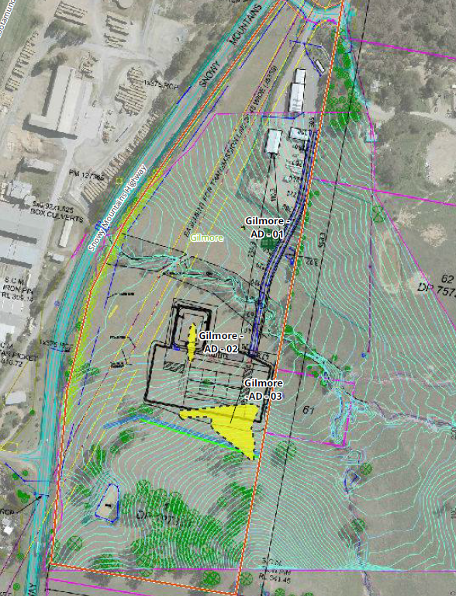

*Figure 2 – Location of the recorded Aboriginal Sites (Source: Biosis)*

The following management measures have therefore been developed with consideration to Ecologically Sustainable Development (ESD) in order mitigate impacts to Aboriginal cultural values identified within the study area:

No further archaeological assessment required for Gilmore-AD-01, Gilmore-

AD-02, and Gilmore-AD-03

Archaeological test excavations have determined that Gilmore-AD-01, Gilmore-AD-02, and Gilmore-AD-03 have limited potential to expand our understanding of the archaeology of the local area or the surrounding region through further investigation. No further investigation of these sites is therefore warranted.

Fencing of archaeological sites and areas of moderate and high archaeological potential that

will not be impacted by the proposed development

The proposed works will not impact Gilmore-AD-01 and will only partially impact Gilmore- AD-03. These sites should therefore be clearly fenced in order to prevent any unintentional impacts to the site over the lifespan of the proposed development. This management strategy will be included within the AHIP recommendations, and a no-go-zone should allow for a five metre buffer around the site extent.

The southern boundary of the proposed works should also be appropriately fenced to ensure the proposed works do not impact on any areas of high or moderate archaeological potential identified within the crest landform.

Apply for an AHIP to impact Gilmore-AD-02, and Gilmore-AD-03

Biosis recommends that an AHIP be obtained for the proposed works which extends across the development footprint. The AHIP should allow for direct impacts to Gilmore-AD-02, and part of Gilmore- AD-03, to occur. The AHIP should be obtained prior to works proceeding. The AHIP should be for a term of 10 years. An AHIP is required for any activities likely to have an impact on Aboriginal objects or Places or cause land to be disturbed for the purposes of discovering an Aboriginal object. Heritage NSW issues AHIPs under Part 6 of the NPW Act.

The application was referred to NSW Heritage who issued their GTAs on 18 June 2021 noting the following:

*We note the reports identify Aboriginal objects were located during archaeological investigations and the reports recommend an Aboriginal Heritage Impact Permit (AHIP) is applied for under the National Parks and Wildlife Act 1974 (NPW Act) to harm objects to allow the proposal to proceed.*

*On review of the Aboriginal Heritage Information Management System (AHIMS) it appears the Aboriginal objects identified have not as yet been registered on the AHIMS database. Mandatory notification of Aboriginal objects is a requirement under s89A of the NPW Act. We recommend the proponent complete the submission of sites identified to the AHIMS database as a priority.*

*The AHIMS search in the Archaeological Report dates to 15 June 2020. AHIMS searches remain current for 12 months. We recommend that a new AHIMS search is completed following submission of the site cards and site numbers are included in reporting at the time of any application. An AHIMS search should be undertaken less than 12 months prior to receipt of any AHIP application to Heritage NSW, to ensure it is current at the time of the application.*

*Based on a review of the information provided by the applicant, we advise that an Aboriginal Heritage Impact Permit (AHIP) under section 90 of the NPW Act can be issued subject to conditions.*

*If the development footprint changes from that shown in the information provided, Heritage NSW must be further consulted to determine whether our GTAs need to be modified.*

*While we are able to issue GTAs, we advise that additional information must be provided by the applicant when submitting the AHIP application.*

As the Aboriginal objects identified on the site are yet to be registered on the AHIMS Website the GTAs were issued for the whole site subject to the provision of additional information at the time of the AHIP application. This includes reporting of the objects to AHIMS so they can be registered prior to the AHIP application. Once registered the AHIP will be issued for the impact of the development on the registered objects as outlined in the ACHA rather than the entire site.

If any changes are proposed to the development footprint Heritage NSW must be consulted to determine whether the GTAs need to be modified.

Compliance with the GTAs has been included in the recommended conditions of consent provided in **Attachment 5**.

1. **Review and update the draft Conditions to specifically refer to recommendations in the specialist reports**

The recommended conditions of consent have been amended to specifically refer to the recommendations of the endorsed specialists reports in Condition 2. Condition 16 further requires the preparation of management plans for the construction and operation of the development.

The condition has been amended to ensure all recommendations of the endorsed specialists report are included in the preparation and implementation of the relevant management plans.

### THE SUITABILITY OF THE SITE

For the reasons discussed in this report, the original assessment report and the information provided within the Environmental Impact Statement and supporting documentation, it considered that the site is suitable for the proposed development on the basis that the site is suitably zoned and maintains an adequate buffer distance from nearby urban and residential areas.

It is considered the proposal will not lead to an increase in land use conflicts with the surrounding agricultural and industrial uses based on the design, operation, proposed mitigation measures and conditions of consent.

The proposed development is compatible with the surrounding area; therefore, the consent authority can be satisfied that the site is suitable for the proposed development.

.

### THE PUBLIC INTEREST

The public interest is served through the detailed assessment of this DA under *the Environmental Planning and Assessment Act 1979*, the *Environmental Planning and Assessment Regulation 2000*, Environmental Planning Instruments, Development Control Plan and policies.

That assessment has demonstrated that the proposed development has addressed the requirements of the relevant planning instruments and development controls applicable to it including the objectives of the zone at the time of lodgement (RU1) and current zone (IN1).

The proposed development has also demonstrated that the site is suitable for the proposal. The proposal aims to provide a facility that will benefit the community by as it will remove a significant volume of materials from the waste stream and process them into useful products and all potential impacts will be appropriately minimised and managed.

Based on the above assessment, the proposal is considered to be in the interest of the public.

### CONCLUSION

The proposed development involves the construction of a waste management facility for the purpose of sorting and composting a maximum of 10,000 tonnes per annum of organic material, including food organics garden organics (FOGO), and associated access, supporting infrastructure and associated site works at Lot 1 DP 197308 Snowy Mountains Highway, Gilmore.

The application is ‘designated development’ and a detailed Environmental Impact Statement (EIS) that addresses the matters required by the Environmental Planning and Assessment Regulation and the NSW Department of Planning and Environment (SEAR’s), has been submitted and assessed.

The application has been assessed in accordance with the provisions of section 4.15 of the Environmental Planning and Assessment Act 1979. The EIS is deemed to satisfactorily address the environmental impacts of the development and the mitigation measures proposed are considered appropriate to minimise any potential detrimental impacts. Overall, it is considered that the proposed development will have an acceptable and minimal environmental impact if constructed and operated in accordance with the conditions of consent and the Environment Protection License conditions of the NSW Environment Protection Authority. Accordingly, it is recommended that development consent be granted, subject to conditions.

### RECOMMENDATION

That the Panel grant consent to DA2021/011 consisting of the construction of a waste management facility for the purpose of sorting and composting organic material and associated site works pursuant to Section 4.16 of the Environmental Planning and Assessment Act 1979 subject to the conditions contained in **Attachment 5** to this report.